Non Disclosure Agreement

This non disclosure agreement is entered into on **December, 02 2020** between **Devlweb Digital Solutions SpA** (Owner) and (Recipient) with the following ID or Passport number:

The Owner acknowledges the Recipient may receive information regarding the Owner’s business, practices, or other properties that may be considered confidential. Therefore, the Parties are in agreement to the following terms and conditions of this agreement.

# Confidentiality

For the duration of this non disclosure agreement, any information the Recipient may come into contact with that is not public knowledge and is made only available through contact with the Owner shall be deemed as confidential information.

This includes any information in regards to vendors, pricing, products, technology, software, or intellectual property.

The Recipient should use common judgment when deciding if information is confidential and above all else shall request approval from the Owner prior to the release of any questionable information.

# Confidentiality Protection

The Recipient understands that the information deemed confidential is of value to the Owner and shall hold all information at the same level of confidentiality as personal information is held.

The Recipient agrees to hold all confidential information made available to standard non disclosure terms and will not make said information available or disclose said information to third party vendors or individuals without the Owner's prior written consent.

The Recipient shall under no circumstances modify or copy confidential information that is made available to them.

# Unauthorized disclosure

In the event any information is found to be disclosed by the Recipient without prior written approval from the Owner, the Owner will be permitted to seek remedies including, but not limited to legal assistance and termination of this agreement.

# Non Circumvention

Upon entering into this non disclosure agreement and for a period of 5 years after the conclusion or termination of this agreement the Recipient shall not partake in business with or solicit business that was made available from the Owner to the Recipient for the purpose of circumvention.

In the event such circumvention occurs the Owner shall be entitled to any and all compensation regarding any transactions that may take place from such events occurrence.

# Return of Information

Upon the conclusion or termination of this agreement the Recipient agrees to return any information deemed confidential and in relation to this non disclosure agreement.

Any information that is unable to be returned must be destroyed immediately following the termination or conclusion of this non disclosure agreement.

# Relationship

This non disclosure agreement shall not serve in any instance as an agreement between the Parties for employment.

The Recipient shall remain as an individual contractor unless otherwise contracted by the Owner directly and shall as so pay all federal and local taxes due for monies received.

# License to Use

The Recipient shall be permitted to use any and all information or products provided by the Owner strictly in the form such property is permitted.

Furthermore all property provided to the Recipient shall remain the Owner's property and shall be treated as such.

The Recipient agrees to hold the Owner harmless in the instance of any loss, damage, theft, or injury for any reason.

This is inclusive of any attorney fees, court costs, hospital fees, and loss of funds that may occur from such negligence.

# Entirety

This non disclosure agreement shall serve as the entire agreement between the Parties and shall prevail over any prior agreements conducted in written or oral form by the Parties.

# Term

The obligations of this non disclosure agreement shall survive indefinitely including through termination or conclusion of this agreement.

# Assignment

The Parties agree to abstain from the sale, transferring, or delegating of any provisions of this agreement to third party individuals without the prior written consent of the responding party.

Any third party individuals entered into this agreement shall be bound by all the terms and conditions contained within this agreement as so.

# Jurisdiction

This non disclosure agreement shall fall under the jurisdiction of **Chile**, furthermore all legal proceedings occurring in relation to this agreement shall be conducted as such.

The prevailing party in such proceedings shall have the opportunity to seek compensation for all court fees associated with said proceedings.

# Notification

Any and all notifications related to this non disclosure agreement shall be produced in person, via courier, or via certified letter to the addresses listed below.

Owner: San Isidro 661, Oficina #2, Santiago, Región Metropolitana, Chile. Recipient: 506/16 S.N Roy, Sahapur, Kolkata -700038, West Bengal, India.

# Agreement

By affixing their electronic signatures below, the Parties acknowledge and agree to any and all provisions included in this non disclosure agreement.

# Owner

Signature:

Devlweb Digital Solutions SpA RUT 76.987.489-5

Santiago, Chile

# Recipient

Signature: Full name: Anuradha Banerjee ID / Passport: Pan Card (Number : AXSPB3462C) Address: 506/16 S.N Roy, Sahapur, Kolkata -700038, West Bengal, India.

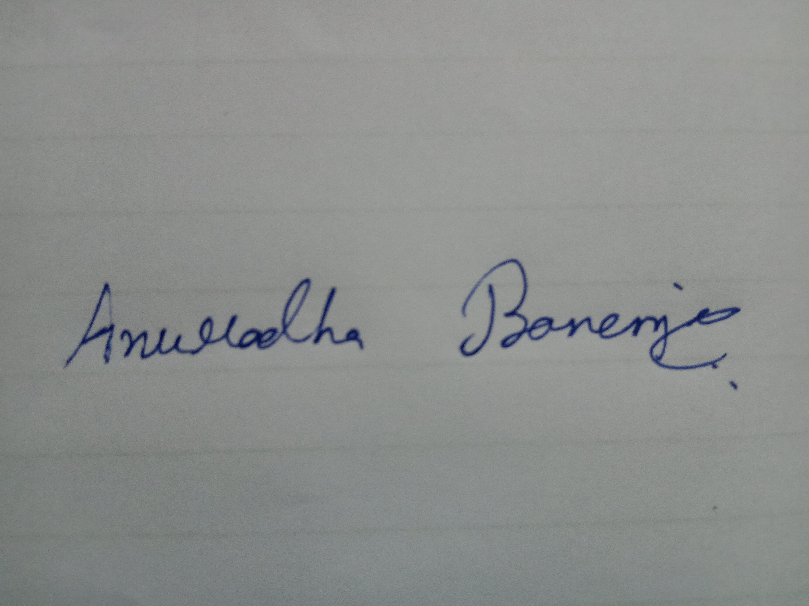

**Important notice:** Please attach along with this agreement, a readable copy of your national ID or Passport, the document can’t be expired.